Hi (CLIENT NAME),

We recently acquired new accounting management software enabling us to build even better client relationships. Our new software provides a secure client portal designed to provide a secure place to exchange documents and sensitive information while offering robust protection for your financial data. Our new firm software undergoes an extensive third-party security audit annually to certify our SOC 2 Type II compliance, ensuring the highest level of security available.

Our client portal does not require any setup on your part! You only need 3 pieces of information to access the portal: your email address, the last 4 digits of your social security number, and your mobile phone number.

To access our portal visit (INSERT YOUR CLIENT PORTAL LINK HERE)

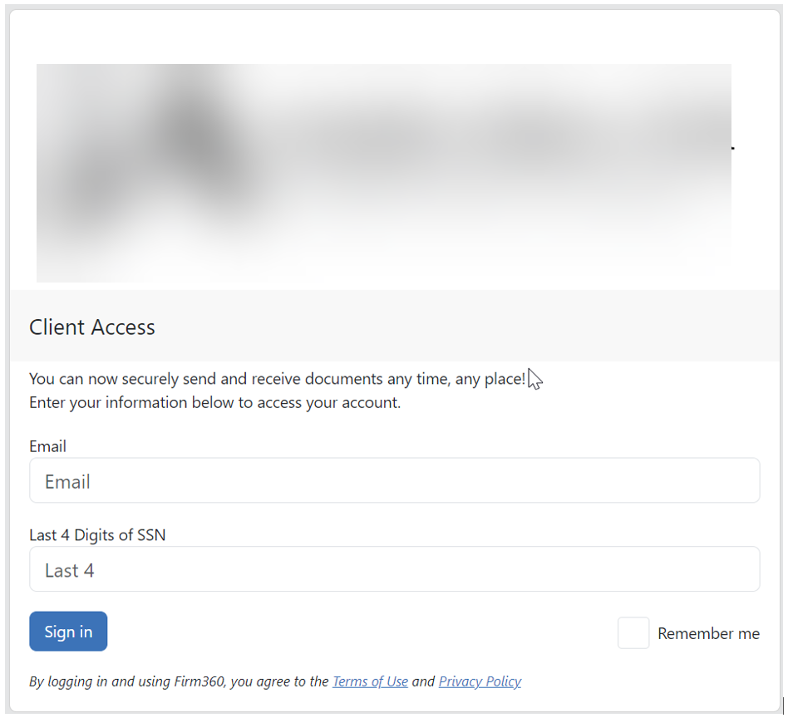

After entering your email address and the last 4 digits of your SSN a verification code will be sent via SMS/text message to your mobile number to enter.

If by chance, you do not receive a verification code that means we are missing some important information from you. Please click where is says “click here for assistance.”

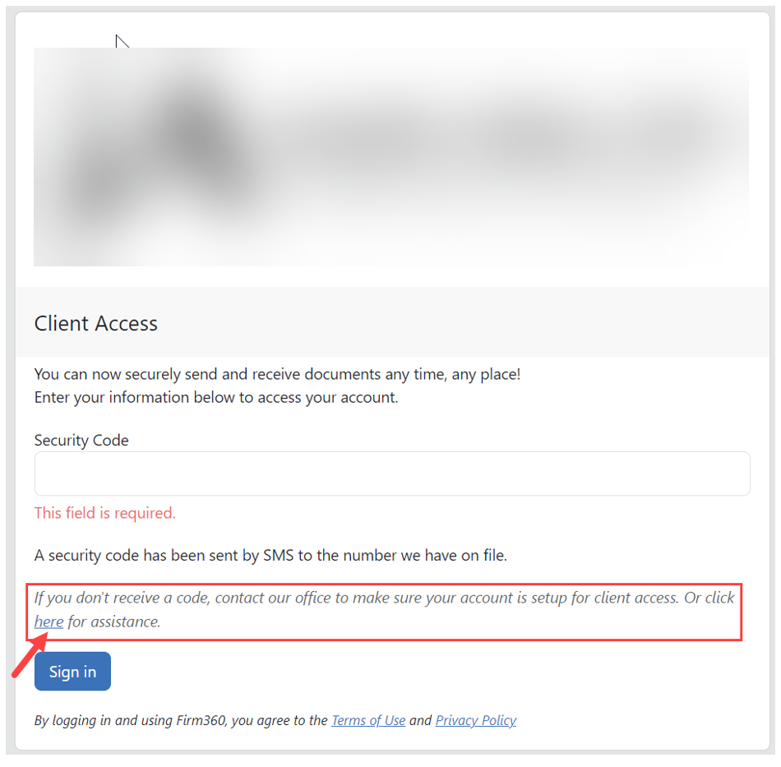
Once you click here you will be prompted to verify your identity and enter your missing information. Our team constantly monitors these requests and will approve your request at our earliest convenience! Once you are approved you will receive an email notification and will be able to login to the portal.

Below is a video link with a brief overview of the client portal.

https://www.loom.com/share/3749817be07b4292bd889b3e6bb8ae79?sid=0b64bfcf-35ea-4aa0-8c0d-a0c1d3e5b3bc

We appreciate your business and hope you love the new client portal as much as we do!

