<Firm Logo>
<Firm Address>
Date
Dear <client name>,
We recently acquired new accounting management software enabling us to build even better client relationships. Our new software provides a secure client portal allowing a seamless method to upload your tax/accounting documents and in return, we can provide you with your tax return or accounting information to you via the portal.
Our client portal does not require any setup on your part! You only need 3 pieces of information to access the portal: your email address, the last 4 digits of your social security number, and your mobile phone number.
To access our portal visit <firmsubdomain>.client.myfirm360.com.
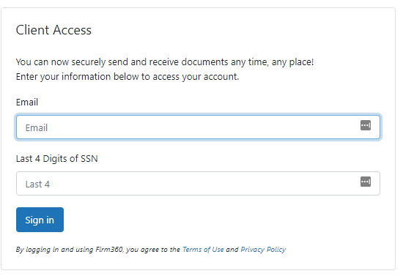
After entering your email address and the last 4 digits of your SSN a verification code will be sent via SMS/text message to your mobile number to enter.
**If by chance, you enter your last 4 digits of your SSN or the verification code incorrectly, you will not receive an error message, you simply cannot gain access. If this happens, please try again.
Once in the client portal:
- 4 tabs across the top(dashboard, documents, invoices, payment methods) On the dashboard you will see:
  - Client Actions are any tasks you need to complete. You can check them off once you have completed them.
  - Documents are listed by type you can add a document by using the “Add a document” button.
  - Open Invoice Balance allows you to see your balance & gives you the ability to pay.
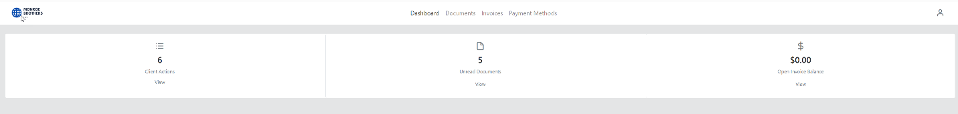

When we upload documents to your client portal for your review, you will receive an email from us similar to the below:
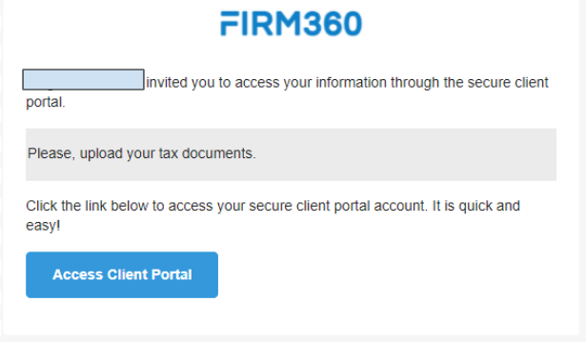
From the Payment Methods tab, you can select Credit Card or ACH. See screenshots below:
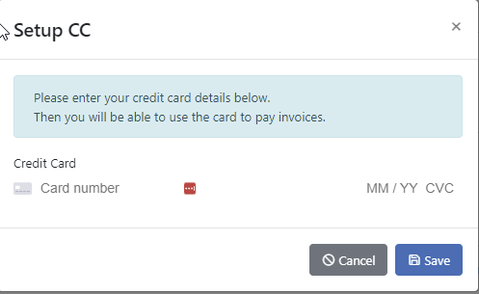
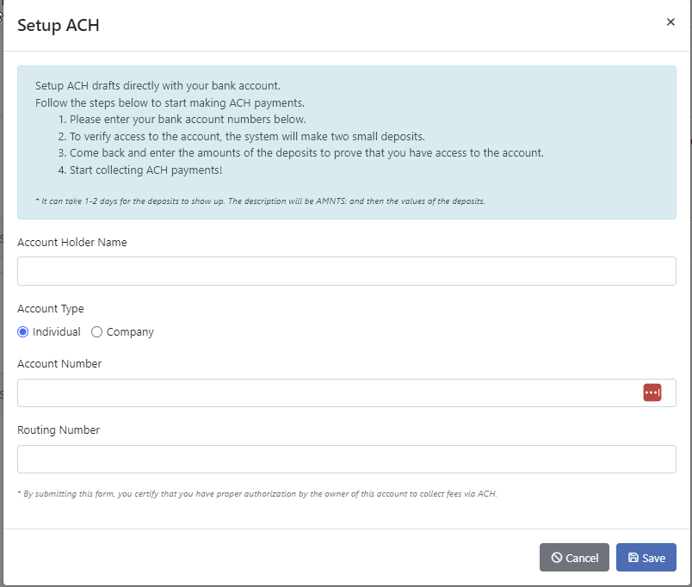
Once you have set up your payment method you can then pay your invoices from the invoices tab. If you are associated with multiple clients, you will be able to pay the balance for each client. See the screenshot below:

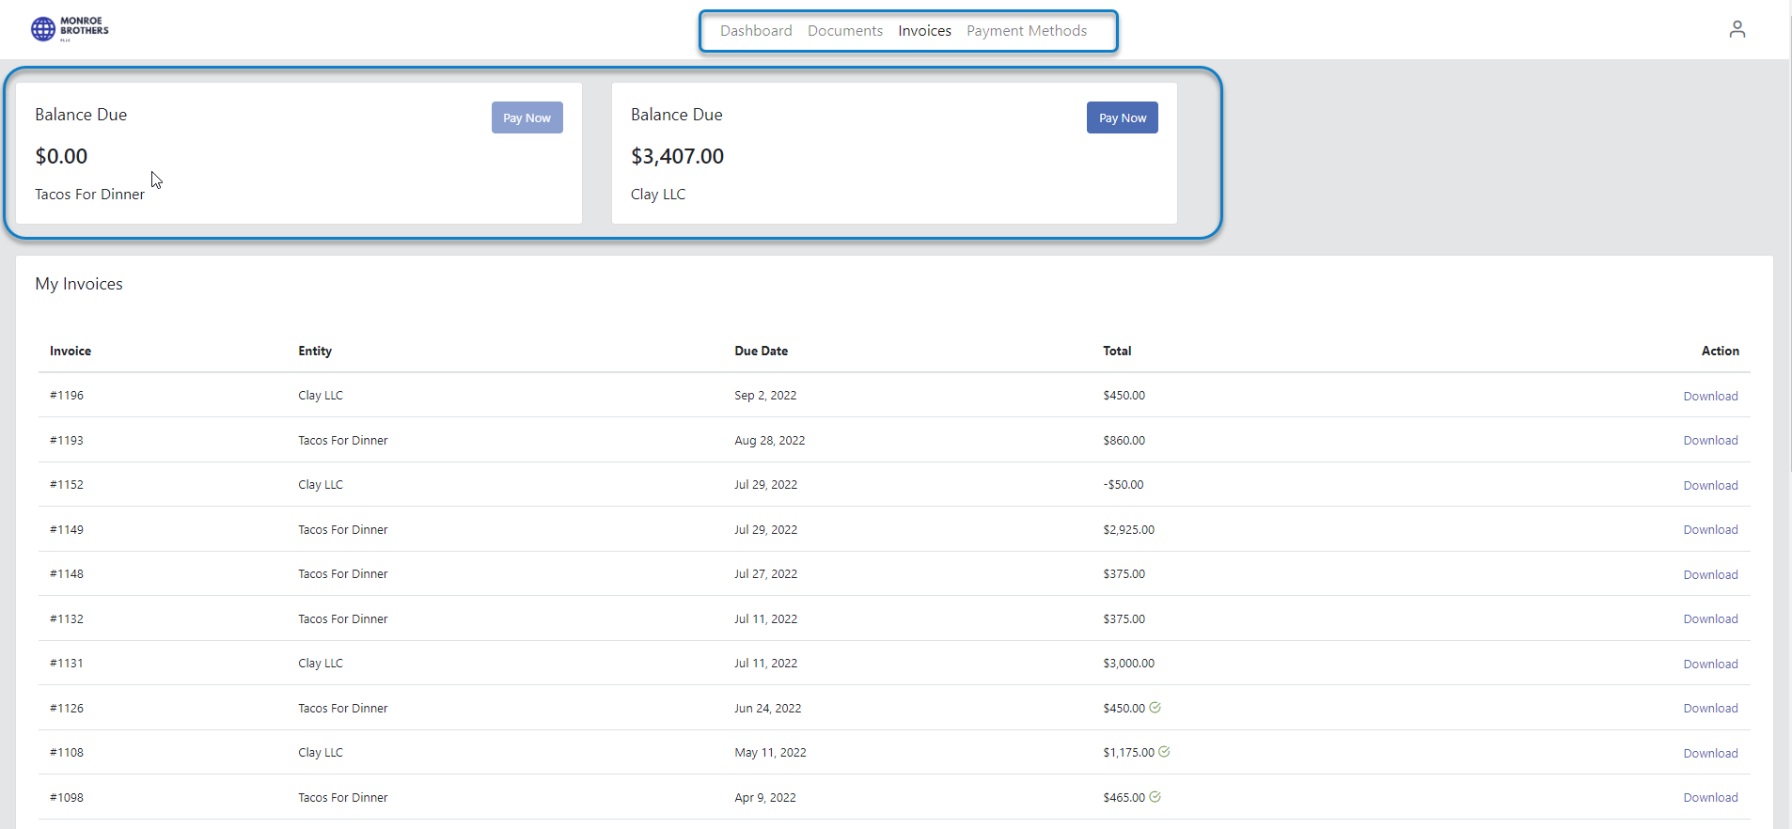
Please, feel free to reach out if you have any questions. Hope you have a great day!

